**Topics: Descriptive Statistics and Probability**

1. Look at the data given below. Plot the data, find the outliers and find out $μ, σ, σ^{2}$

|  |  |
| --- | --- |
| **Name of company** | **Measure X** |
| Allied Signal | 24.23% |
| Bankers Trust | 25.53% |
| General Mills | 25.41% |
| ITT Industries | 24.14% |
| J.P.Morgan & Co. | 29.62% |
| Lehman Brothers | 28.25% |
| Marriott | 25.81% |
| MCI | 24.39% |
| Merrill Lynch | 40.26% |
| Microsoft | 32.95% |
| Morgan Stanley | 91.36% |
| Sun Microsystems | 25.99% |
| Travelers | 39.42% |
| US Airways | 26.71% |
| Warner-Lambert | 35.00% |

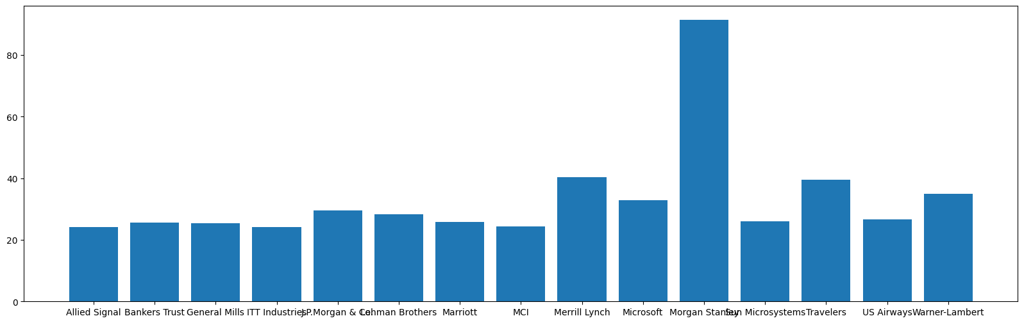

MORGAIN STANLEY IS THE OUTLIER WITH 91.36%, AS ALL OTHERS ARE BETWEEN THE RANGE OF 24%-40%

|  |  |
| --- | --- |
| MEAN | 0.332713 |
| STD | 0.169454 |
| VAR | 0.028715 |



Answer the following three questions based on the box-plot above.

1. What is inter-quartile range of this dataset? (please approximate the numbers) In one line, explain what this value implies.

Ans:  **(Inter-Quartile Range) IQR IS THE RANGE BETWEEN UQ AND LQ i.e Q3 – Q1 = 12 – 5 = 7**

1. What can we say about the skewness of this dataset?

Ans: Positively skewed(right-skewed data)

1. If it was found that the data point with the value 25 is actually 2.5, how would the new box-plot be affected?

Ans: There would be no outliers, as for now data is right-skewed If 25 is taken as 2.5 it will close to normally distributed data.



Answer the following three questions based on the histogram above.

1. Where would the mode of this dataset lie?

**Ans: The mode of the dataset is between 5-10(approx. 4-8)**

1. Comment on the skewness of the dataset.

Ans: **Right skewed data**

1. Suppose that the above histogram and the box-plot in question 2 are plotted for the same dataset. Explain how these graphs complement each other in providing information about any dataset.

Ans: **Both the data-plots has outlier of 25 and both are right-skewed data**

1. AT&T was running commercials in 1990 aimed at luring back customers who had switched to one of the other long-distance phone service providers. One such commercial shows a businessman trying to reach Phoenix and mistakenly getting Fiji, where a half-naked native on a beach responds incomprehensibly in Polynesian. When asked about this advertisement, AT&T admitted that the portrayed incident did not actually take place but added that this was an enactment of something that “could happen.” Suppose that one in 200 long-distance telephone calls is misdirected. What is the probability that at least one in five attempted telephone calls reaches the wrong number? (Assume independence of attempts.)

**Ans: Probability of misdirected calls is 1 in 200 P(x)=1/200**

**Probability of not misdirected calls is 1-P(x) i.e 1-1/200=199/200=0.995**

**When n=5**

**As independence of events 1-(0.995)^5**

**=0.02475=2%chances**

1. Returns on a certain business venture, to the nearest $1,000, are known to follow the following probability distribution

|  |  |
| --- | --- |
| x | P(x) |
| -2,000 | 0.1 |
| -1,000 | 0.1 |
| 0 | 0.2 |
| 1000 | 0.2 |
| 2000 | 0.3 |
| 3000 | 0.1 |

1. What is the most likely monetary outcome of the business venture?

Ans: Monetary outcome i.e highest probability of occurrence=$2000

1. Is the venture likely to be successful? Explain

Ans: There is 60% of chance of venture being successful as P(x)=0.1+0.3+02=0.6.i.e 60%

What is the long-term average earning of business ventures of this kind? Explain

Ans: **Long term average i.e the Expected Value which is given by** **Sum (X * P(X)) so avg earning of business is 800$**

1. What is the good measure of the risk involved in a venture of this kind? Compute this measure

Ans: Risk involved in a venture,

By using formula,

Var (X) = E(X²) - { E(X) }²

SD = √Var = **$ 1870**

Hence, **Risk is high.**